|  |
| --- |
|  |
| **INTRODUCTION TO INSTRUMENTATION & CONTROL ENGINEERING INTRODUCTION TO INSTRUMENTATION & CONTROL ENGINEERING**  For internal purpose only |
| |  |  |  | | --- | --- | --- | | asusryzen5.amd@hotmail.com | 8/17/25 | Internal course | |

Contents

PART I – INTRODUCTION TO INSTRUMENTATION & CONTROL ENGINEERING 3

1.1 What is Instrumentation & Control Engineering? 3

1.2 Role of I&C Engineer in EPC and Industrial Projects 4

1.3 Overview of Key Industries 4

1.4 The Evolution of Instrumentation – From Pneumatics to Digital Systems 5

1.5 Responsibilities of an Instrument Engineer 5

1.6 Design & Engineering Deliverables 6

1.7 Procurement Support & Vendor Coordination 6

1.8 Construction, Installation & Field Support 6

1.9 Testing, Commissioning & Startup 6

1.10 Operation & Maintenance Support 7

1.11 Software Tools Commonly Used 7

Summary of Part I: 7

PART II – FUNDAMENTALS OF INSTRUMENTATION 8

2.1 Basic Measurement Principles 8

2.2 Pressure Measurement 8

2.3 Temperature Measurement 8

2.4 Flow Measurement 9

2.5 Level Measurement 9

2.6 Physical Properties and Measurement Units 10

2.7 Process Variables and Signal Types 10

2.8 Sensor Technologies & Transducers 11

✅ Summary of Part II 11

3.2 CONTROL THEORY BASICS 12

3.3 Controllers – PID and Advanced Control 12

3.4 Distributed Control Systems (DCS) 13

3.5 Programmable Logic Controllers (PLC) 13

3.6 Safety Instrumented Systems (SIS) and Emergency Shutdown (ESD) 13

3.7 Industrial Communication Protocols 14

3.8 Summary of Part III 14

PART IV – ENGINEERING DELIVERABLES & PROJECT ROLE 15

4.1 Introduction 15

4.2 P&ID (Piping & Instrumentation Diagram) Interpretation 15

4.3 Instrument Index, I/O List, and Datasheets 15

4.4 Material Requisition & Vendor Documents 16

4.5 Instrument Sizing & Selection 16

4.6 Hook-Up Drawings & Installation Standards 16

4.7 Instrument Cable & Junction Box Layouts 17

4.8 Control Room Layout & I/O Module Allocation 17

4.9 Role of I&C Engineer Across Project Phases 17

4.10 Summary of Part IV 18

5.2 International Standards in Instrumentation 19

5.3 Hazardous Area Classification 19

5.4 Safety Integrity Level (SIL) & Functional Safety 20

5.5 Control System Cybersecurity 20

5.6 Summary of Part V 21

PART VI – PRACTICAL ENGINEERING & FIELD WORK 22

6.1 Introduction 22

6.2 Calibration & Testing Procedures 22

6.3 Loop Checking & Commissioning 22

6.4 Troubleshooting Instrumentation Systems 23

6.5 Maintenance & Reliability of Control Systems 23

6.6 Case Studies – Common Issues & Solutions 24

6.7 Summary of Part VI 24

PART VII – CAREER PATH, SKILLS & GROWTH 25

7.1 Introduction 25

7.2 Skill Set of an Instrument Engineer 25

7.3 Software Tools for Instrument Engineers 26

7.4 Project Management Basics for I&C Engineers 26

7.5 Career Growth Opportunities 27

7.6 Career Development Strategies 27

7.7 Summary of Part VII 28

8.1 GLOSSARY OF INSTRUMENTATION TERMS 29

8.2 Common Instrument Symbols & Abbreviations 29

8.3 Sample Datasheets & Specifications 32

8.4 Recommended Books 32

8.5 Standards & Codes Reference 32

8.6 Online Resources & Learning Platforms 33

8.7 Engineering Templates & Checklists 33

8.8 Summary of Part VIII 33

# PART I – INTRODUCTION TO INSTRUMENTATION & CONTROL ENGINEERING

## 1.1 What is Instrumentation & Control Engineering?

Instrumentation and Control (I&C) Engineering is the discipline that deals with the measurement, monitoring, and regulation of physical and chemical processes. It provides the “eyes and ears” of an industrial plant, allowing operators and automated systems to know **what is happening inside a process** and take actions to keep it safe, reliable, and efficient.

At its core, instrumentation refers to the **measurement of process variables** such as pressure, temperature, flow, and level. Control engineering, on the other hand, is concerned with **maintaining these variables** within desired limits through feedback, automation, and advanced control systems.

Without instrumentation and control, modern industries such as oil & gas, power generation, water treatment, and manufacturing would not be able to function at today’s level of complexity or safety.

## 1.2 Role of I&C Engineer in EPC and Industrial Projects

An I&C engineer plays a critical role in **EPC (Engineering, Procurement, and Construction) projects** as well as in **operational plants**. Their tasks span across the entire lifecycle of an industrial facility:

* **Engineering Phase**: Designing measurement and control systems, selecting instruments, preparing datasheets, and creating project deliverables such as P&IDs and instrument indexes.
* **Procurement Phase**: Supporting vendor selection, reviewing technical bids, and ensuring that purchased instruments comply with specifications and standards.
* **Construction & Installation Phase**: Providing installation drawings, hook-ups, and field support for contractors.
* **Commissioning & Startup**: Calibrating and testing instruments, conducting loop checks, verifying interlocks, and ensuring control systems are operational.
* **Operation & Maintenance**: Assisting plant teams in troubleshooting, optimizing system performance, and ensuring regulatory compliance.

This end-to-end involvement makes I&C engineers **multi-disciplinary professionals** who bridge process, electrical, and mechanical domains.

## 1.3 Overview of Key Industries

Instrumentation and control are universally applied across industries, but the **focus and challenges** vary depending on the sector:

* **Oil & Gas**: Measurement of multiphase flows, custody transfer metering, explosion-proof instruments, and advanced process control for refineries.
* **Petrochemicals**: High-temperature and high-pressure reactors, emissions monitoring, and analyzer integration.
* **Power Generation**: Turbine control systems, boiler instrumentation, safety interlocks, and environmental monitoring.
* **Water & Wastewater**: Level, flow, pH, turbidity sensors, and automated pumping stations.
* **Manufacturing & Pharmaceuticals**: Batch control, cleanroom monitoring, precise dosing, and validation instrumentation.

This variety makes I&C a **versatile career field** with opportunities across different global industries.

## 1.4 The Evolution of Instrumentation – From Pneumatics to Digital Systems

Instrumentation has evolved dramatically over the last century:

1. **Pneumatic Era (1920s–1960s)**
   * Instruments operated using compressed air signals (3–15 psi).
   * Simple and robust, but limited in range and integration.
2. **Electronic Analog Era (1960s–1980s)**
   * Introduction of 4–20 mA DC signals.
   * Enabled longer transmission distances and more precise measurements.
3. **Digital & Smart Instruments (1980s–2000s)**
   * Microprocessor-based devices.
   * HART communication allowed digital data superimposed on analog signals.
4. **Fieldbus & Integration (2000s–Present)**
   * Full digital communication (Foundation Fieldbus, Profibus, Modbus TCP).
   * Smart diagnostics, asset management, and self-calibration.
5. **Industry 4.0 (Emerging)**
   * IoT sensors, wireless instrumentation, cloud-based monitoring, and predictive maintenance using AI.

This journey reflects the constant drive for **accuracy, reliability, and connectivity** in industrial automation.

## 1.5 Responsibilities of an Instrument Engineer

An instrument engineer’s responsibilities extend beyond just selecting devices. Key responsibilities include:

* Reviewing **process documents (PFDs, P&IDs)** to identify measurement and control requirements.
* Preparing **instrument datasheets, material requisitions, and specifications**.
* Performing **instrument sizing and selection** (valves, flowmeters, transmitters).
* Ensuring **compliance with international codes and standards** (ISA, IEC, API, ISO).
* Coordinating with **vendors, contractors, and clients**.
* Supporting **construction, installation, and site inspections**.
* Conducting **calibration, loop checking, and functional testing**.
* Providing **operation & maintenance support** during plant lifecycle.

## 1.6 Design & Engineering Deliverables

I&C engineers generate a wide variety of deliverables during the project lifecycle, including:

* **P&ID review and mark-up**.
* **Instrument index** (master list of instruments).
* **I/O list** for control systems.
* **Instrument datasheets and specifications**.
* **Cable schedules, junction box layouts, and loop diagrams**.
* **Hook-up drawings and installation details**.
* **Control system configuration documents**.
* **Cause & Effect diagrams for safety systems**.

These deliverables are the **blueprints for construction and operation**, ensuring that the plant runs as designed.

## 1.7 Procurement Support & Vendor Coordination

In the procurement stage, the I&C engineer:

* Prepares **Material Requisition (MR)** for instruments.
* Reviews **vendor bids and technical documents**.
* Coordinates **vendor drawings and datasheets approval**.
* Ensures instruments meet **standards, hazardous area certifications, and performance requirements**.

Vendor coordination is critical to avoid **delays, mismatches, and site rework**.

## 1.8 Construction, Installation & Field Support

During construction:

* I&C engineers ensure **instruments are installed as per drawings and standards**.
* They provide **field support for cable routing, tubing, junction box connections, and control panel installation**.
* They verify **instrument orientation, accessibility, and maintainability**.

This phase requires **collaboration with civil, piping, and electrical teams**.

## 1.9 Testing, Commissioning & Startup

In commissioning:

* Instruments are **calibrated** using field calibrators.
* **Loop checks** are performed from field instrument to control system.
* **Function tests** verify interlocks, trips, and alarms.
* **Simulation and dry runs** are conducted before introducing live process fluids.

The I&C engineer ensures a **smooth transition from construction to operation**.

## 1.10 Operation & Maintenance Support

After startup, I&C engineers continue to play a role:

* Supporting **maintenance teams** with calibration schedules.
* Monitoring **instrument performance and diagnostics**.
* Troubleshooting **field issues and control logic problems**.
* Assisting with **plant modifications and revamps**.

Reliability and safety of the plant depend heavily on well-maintained instrumentation.

## 1.11 Software Tools Commonly Used

While Part I focuses on concepts and roles, in practice, engineers also rely on tools:

* **MS Project / Primavera P6** – project scheduling.
* **MS Excel / Power BI** – deliverable tracking, cost estimation, reporting.
* **AutoCAD / SmartPlant P&ID** – reviewing and updating P&IDs.
* **SPI/INtools** – preparing instrument indexes and datasheets.
* **EDMS (Electronic Document Management Systems)** – handling vendor docs and approvals.

## Summary of Part I:

Instrumentation & Control Engineering is a multidisciplinary field central to industrial automation. From the **design table to plant operations**, I&C engineers ensure safe, efficient, and reliable processes. They are responsible for **engineering deliverables, procurement, construction, commissioning, and maintenance support**, using both **technical expertise and software tools** to manage complex projects.

# PART II – FUNDAMENTALS OF INSTRUMENTATION

## 2.1 Basic Measurement Principles

Every industrial process is defined by **measurable quantities**. These measurable parameters — pressure, temperature, flow, and level — are called **process variables (PVs)**. The ability to measure them accurately is the foundation of automation.

Key principles include:

* **Accuracy** – closeness of measurement to true value.
* **Precision** – repeatability of a measurement.
* **Resolution** – smallest detectable change.
* **Range** – span between minimum and maximum measurable values.
* **Sensitivity** – response of an instrument to a change in variable.

For example, a pressure transmitter in a refinery reactor may be required to measure pressures up to 150 bar with an accuracy of ±0.1%. Such requirements demand careful **instrument selection and calibration**.

## 2.2 Pressure Measurement

Pressure is one of the most critical parameters in industrial processes — boilers, reactors, compressors, and pipelines all rely on safe and accurate pressure monitoring.

**Common Pressure Measurement Methods:**

* **Bourdon tube gauges** (mechanical, analog).
* **Strain gauge / piezoelectric sensors** (electronic, precise).
* **Differential Pressure (DP) transmitters** for flow and level measurements.
* **Smart pressure transmitters** with digital communication (HART, Fieldbus).

**Applications:**

* Monitoring steam pressure in power plants.
* Custody transfer metering in gas pipelines.
* Safety relief system monitoring.

🔗 **Reference:**

* ISA RP 37.2 – Pressure Transmitter Guidelines
* IEC 61298 – Process Measurement Standards

📺 **YouTube:** [Pressure Measurement Basics – InstrumentationTools](https://www.youtube.com/watch?v=SPz1A8jXKiw)

## 2.3 Temperature Measurement

Temperature directly affects reaction rates, energy efficiency, and material properties. It is therefore a fundamental measurement in **chemical, power, and food industries**.

**Common Temperature Sensors:**

* **Thermocouples (TCs):** Suitable for high temperatures up to 1700°C.
* **Resistance Temperature Detectors (RTDs):** High accuracy, good for −200 to 600°C.
* **Infrared Sensors / Pyrometers:** Non-contact temperature measurement.
* **Thermistors:** Highly sensitive, narrow range.

**Applications:**

* Reactor temperature monitoring in petrochemical plants.
* Furnace and turbine monitoring in power generation.
* Cold storage and pharmaceutical manufacturing.

🔗 **Reference:**

* ASTM E230 – Thermocouple Standards
* IEC 60751 – RTD Standardization

📺 **YouTube:** [RTD and Thermocouple Explained – RealPars](https://www.youtube.com/watch?v=tQuRG9IhHw0)

## 2.4 Flow Measurement

Flow measurement is essential for **material balance, efficiency, and billing** (custody transfer). It can be measured in **volumetric** (m³/hr) or **mass flow** (kg/s) terms.

**Flow Measurement Methods:**

* **Differential Pressure (Orifice, Venturi, Flow Nozzles).**
* **Turbine Flowmeters.**
* **Electromagnetic Flowmeters (EMF).**
* **Ultrasonic Flowmeters.**
* **Coriolis Mass Flowmeters (direct mass flow).**

**Applications:**

* Natural gas pipelines (custody transfer).
* Feedwater flow in boilers.
* Slurry and wastewater monitoring.

🔗 **Reference:**

* ISO 5167 – Flow Measurement by Differential Pressure Devices
* API MPMS – Custody Transfer Measurement

📺 **YouTube:** [Types of Flow Measurement Devices – RealPars](https://www.youtube.com/watch?v=gpq_PZCqwxw)

## 2.5 Level Measurement

Level measurement ensures **safe operation of tanks, vessels, and separators**. Overflow, underflow, or incorrect level readings can lead to severe operational and safety issues.

**Methods of Level Measurement:**

* **Hydrostatic (DP transmitters).**
* **Float & Displacer.**
* **Capacitance Level Sensors.**
* **Radar Level Transmitters (non-contact, high accuracy).**
* **Ultrasonic Level Sensors.**

**Applications:**

* Oil-water separation in separators.
* Storage tank inventory control.
* Boiler drum level measurement.

**Reference:**

* API 3.1B – Tank Level Measurement Standards
* IEC 60079 – Hazardous Area Considerations for Level Instruments

**YouTube:** [Radar vs. Ultrasonic Level Measurement – Endress+Hauser](https://www.youtube.com/watch?v=6woMP_E8Yho)

## 2.6 Physical Properties and Measurement Units

Instrumentation relies on a **universal system of units** to maintain consistency.

* **Pressure**: Pascal (Pa), bar, psi.
* **Temperature**: Celsius (°C), Fahrenheit (°F), Kelvin (K).
* **Flow**: m³/hr, L/min, SCFM, kg/s.
* **Level**: meters (m), percentage (% of tank height).

Engineers must also understand **standard conditions** (STP, NTP) for gas and fluid properties.

🔗 **Reference:**

* NIST Reference on Constants, Units, and Uncertainty (NIST.gov)

## 2.7 Process Variables and Signal Types

The four main **process variables** are:

* **Pressure (P)**
* **Temperature (T)**
* **Flow (F)**
* **Level (L)**

These are transmitted using signals:

* **Analog signals:** 4–20 mA (standard).
* **Digital signals:** HART, Foundation Fieldbus, Modbus, Profibus.
* **Pneumatic signals:** 3–15 psi (legacy systems).

Understanding signal types is essential for integration into **PLC/DCS systems**.

📺 **YouTube:** [Analog vs. Digital Signals in Instrumentation – RealPars](https://www.youtube.com/watch?v=mbJdV8a5V5U)

## 2.8 Sensor Technologies & Transducers

A **sensor** detects physical changes, while a **transducer** converts it into an electrical signal.

**Examples:**

* **Pressure transducer**: Diaphragm + strain gauge → voltage/current output.
* **Temperature transducer**: RTD or thermocouple → resistance/voltage signal.
* **Flow transducer**: Ultrasonic waves → electronic pulses.

Modern sensors often include **self-diagnostics** and **digital communication**.

🔗 **Reference:**

* IEC 60079 – Instrumentation in Explosive Atmospheres
* ISA 20.00.01 – Instrumentation Symbols and Identification

📺 **YouTube:** [How Sensors Work – National Instruments](https://www.youtube.com/watch?v=w0SmcJZB4ZQ)

## ✅ Summary of Part II

The **fundamentals of instrumentation** revolve around measuring and transmitting **pressure, temperature, flow, and level** accurately. These four primary process variables are the backbone of industrial automation. I&C engineers must understand **measurement principles, units, signal transmission, and sensor technologies**, as well as the **standards and safety considerations** governing their applications.

## 3.2 CONTROL THEORY BASICS

**Open-Loop Control**

In open-loop systems, there is no feedback. The control action is independent of the actual process output.

Example: A simple timer controlling the ON/OFF operation of a motor, without monitoring the process.

**Closed-Loop Control**

Closed-loop systems (feedback systems) continuously measure the process variable, compare it with the setpoint, and adjust the input to minimize error.

Example: A temperature controller in a furnace that adjusts the fuel flow based on measured temperature.

Closed-loop systems form the foundation of industrial process control, ensuring stability, efficiency, and safety.

## 3.3 Controllers – PID and Advanced Control

The most widely used controller in industry is the **PID controller** (Proportional, Integral, Derivative). It is applied in more than 90% of process loops in oil and gas, power plants, and manufacturing industries.

* **Proportional Control (P):** Corrects proportionally to error.
* **Integral Control (I):** Eliminates steady-state error by integrating error over time.
* **Derivative Control (D):** Predicts error based on its rate of change, improving stability.

Beyond PID, advanced control strategies include:

* **Model Predictive Control (MPC).**
* **Fuzzy Logic Control.**
* **Adaptive Control Systems.**

These advanced methods are used in complex and dynamic processes, such as refining units and power generation systems.

Reference:

* K. Ogata, *Modern Control Engineering*, Prentice Hall.

YouTube: [PID Controller Explained – RealPars](https://www.youtube.com/watch?v=wkfEZmsQqiA)

## 3.4 Distributed Control Systems (DCS)

A **DCS** is a digital platform designed for plant-wide control and monitoring. It integrates thousands of input/output (I/O) signals into a centralized system with multiple operator stations.

Key features of DCS:

* **Redundancy:** High availability through backup systems.
* **Scalability:** Suitable for small plants or large refineries.
* **Integration:** Links with SCADA, safety systems, and enterprise IT.
* **Human-Machine Interface (HMI):** Provides operators with visualization, alarms, and reports.

Applications include refineries, chemical plants, power plants, and water treatment facilities.

Reference:

* ISA-88 and ISA-95 standards on control system architecture.

YouTube: [What is a DCS? – RealPars](https://www.youtube.com/watch?v=XY6M4jXn7yE)

## 3.5 Programmable Logic Controllers (PLC)

A **PLC** is an industrial computer designed for automation of electromechanical processes. Unlike DCS, PLCs are often used for **discrete control**, such as machinery, packaging, or material handling.

Key characteristics:

* Rugged, designed for harsh industrial environments.
* Real-time operation with scan cycles in milliseconds.
* Programming languages follow IEC 61131-3: Ladder Logic, Function Block, Structured Text, etc.
* Often integrated with Supervisory Control and Data Acquisition (SCADA) systems.

Applications: conveyor systems, compressors, pumps, and safety interlocks.

Reference:

* IEC 61131-3 – Standard for PLC Programming Languages.

YouTube: [PLC Basics Explained – RealPars](https://www.youtube.com/watch?v=Jd3Jb9D7y3I)

## 3.6 Safety Instrumented Systems (SIS) and Emergency Shutdown (ESD)

While process control aims to optimize efficiency, safety instrumented systems are designed to **protect people, environment, and assets**.

* **Safety Instrumented Systems (SIS):** Independent from the main control system, implementing safety functions such as emergency shutdowns, burner management, or high-pressure trip systems.
* **Emergency Shutdown (ESD):** A critical part of SIS that safely brings the plant to a safe condition in case of hazardous events.
* **Safety Integrity Level (SIL):** Classification of risk reduction capability according to IEC 61511.

Reference:

* IEC 61508 and IEC 61511 – Functional Safety Standards.

YouTube: [SIS and ESD Explained – InstrumentationTools](https://www.youtube.com/watch?v=XSp2jMcTIQw)

## 3.7 Industrial Communication Protocols

Modern automation relies on reliable communication networks. Key protocols include:

* **HART (Highway Addressable Remote Transducer):** Hybrid analog + digital communication.
* **Foundation Fieldbus:** Fully digital, device-level communication.
* **Modbus:** Widely used open protocol for simple device integration.
* **Profibus / Profinet:** Siemens protocol, widely used in manufacturing and process industries.
* **Ethernet/IP and OPC UA:** Modern protocols for IT/OT integration and Industry 4.0 applications.

Understanding these protocols is essential for I&C engineers working in system integration and digitalization projects.

Reference:

* ISA-100 and IEC 61784 – Industrial Communication Standards.

YouTube: [Industrial Communication Protocols – RealPars](https://www.youtube.com/watch?v=EoUL3V0R0XQ)

## 3.8 Summary of Part III

Control systems are the heart of industrial automation. Starting from basic open and closed-loop control, engineers implement controllers such as PID and advanced strategies for optimal operation. Distributed Control Systems (DCS) manage large, continuous processes, while Programmable Logic Controllers (PLC) excel in discrete automation. Safety Instrumented Systems (SIS) ensure protection beyond process optimization, and communication protocols provide the backbone for integration.

# PART IV – ENGINEERING DELIVERABLES & PROJECT ROLE

## 4.1 Introduction

Instrumentation and Control (I&C) engineers play a central role in the execution of industrial projects, especially in **EPC (Engineering, Procurement, and Construction)** phases. Their work is highly documentation-driven, as the design must be clearly communicated across engineering, vendors, procurement, construction, and operations teams.

This chapter explains the main **engineering deliverables** produced by I&C engineers, and their **role across the project lifecycle**—from conceptual design to construction and commissioning.

## 4.2 P&ID (Piping & Instrumentation Diagram) Interpretation

The **P&ID** is the backbone of instrumentation design. It provides a graphical representation of the process flow, equipment, piping, and all associated instruments.

**Key Instrumentation Elements on a P&ID:**

* **Instrument tags and symbols** (ISA S5.1 standard).
* **Control loops** (temperature control loops, pressure control loops, etc.).
* **Interfaces with mechanical equipment** such as pumps, compressors, and reactors.
* **Safety systems and interlocks.**

An I&C engineer must be skilled in interpreting P&IDs, as all subsequent deliverables (instrument index, datasheets, I/O list) are derived from them.

**Reference:** ISA P&ID Symbols Standard – ISA S5.1

YouTube: [How to Read P&ID – InstrumentationTools](https://www.youtube.com/watch?v=0wH2R6DqKfA)

## 4.3 Instrument Index, I/O List, and Datasheets

**Instrument Index**

The **Instrument Index** is the master list of all instruments in a project. It includes instrument tag numbers, service descriptions, process data, and location (field or control room).

**I/O List**

The **Input/Output List** details how each instrument connects to the control system. It specifies:

* Signal type (analog, digital, pulse).
* Range and scaling.
* Associated control system module and channel.

**Datasheets**

Each instrument has a **datasheet**, summarizing its technical specifications. This document is essential for procurement and vendor communication. For example, a pressure transmitter datasheet includes measurement range, accuracy, material of wetted parts, electrical connection, and process connection.

**Reference:** ISA Datasheet Standards

YouTube: [Instrument Index and Datasheet Explanation – RealPars](https://www.youtube.com/watch?v=dspJ8xDK7Zc)

## 4.4 Material Requisition & Vendor Documents

Once datasheets are finalized, the I&C engineer prepares the **Material Requisition (MR)** for procurement.

**MR Includes:**

* Datasheets of instruments.
* Technical specifications.
* Quantity and delivery requirements.
* Vendor document requirements (GA drawings, calibration certificates, manuals).

Vendor coordination is a major responsibility of the I&C engineer. This includes reviewing vendor documents, ensuring compliance with specifications, and resolving technical queries.

**Reference:** API Recommended Practice 551 – *Process Measurement Instrumentation*.

## 4.5 Instrument Sizing & Selection

I&C engineers perform **instrument sizing calculations** to ensure correct specification and functionality.

**Common Sizing Activities:**

* **Control Valves:** Flow coefficient (Cv) calculation, pressure drop analysis, noise/choked flow considerations.
* **Flowmeters:** Selection between orifice, Coriolis, turbine, or ultrasonic based on accuracy and process.
* **Analyzers:** Selection for gas chromatographs, pH meters, oxygen analyzers, etc.

Proper selection ensures accuracy, reliability, and longevity of instrumentation.

YouTube: [Control Valve Sizing Basics – Emerson](https://www.youtube.com/watch?v=E2_gYbRZ5Uk)

## 4.6 Hook-Up Drawings & Installation Standards

**Hook-up drawings** are detailed diagrams showing how each field instrument is installed, including:

* Impulse tubing arrangements for pressure transmitters.
* Thermowell installation for temperature sensors.
* Cable routing and junction box connections.
* Instrument air supply for pneumatic devices.

They follow international standards such as **ISA, IEC, and ISO**, as well as client-specific installation practices.

YouTube: [Hook-up Drawing Explanation – InstrumentationTools](https://www.youtube.com/watch?v=Xa8gjO0rU_M)

## 4.7 Instrument Cable & Junction Box Layouts

Instrumentation requires extensive cabling between field instruments, junction boxes, and control rooms. Deliverables include:

* **Cable block diagrams** showing interconnections.
* **Cable routing layouts** (often developed in coordination with electrical engineers).
* **Junction box drawings** specifying terminations.

These documents ensure proper field installation and minimize errors during construction.

## 4.8 Control Room Layout & I/O Module Allocation

I&C engineers also contribute to the **control system architecture** by defining:

* Control room layout (operator consoles, marshalling racks, servers).
* Allocation of signals to I/O modules in PLC/DCS systems.
* Redundancy requirements for critical signals.

This ensures that the control room is ergonomically designed and technically compliant with project requirements.

## 4.9 Role of I&C Engineer Across Project Phases

An Instrumentation Engineer’s role is not limited to design. Their involvement spans across all EPC stages:

* **Engineering Phase:** Preparing deliverables, performing sizing, and coordinating with other disciplines.
* **Procurement Phase:** Preparing material requisitions, reviewing vendor offers, and evaluating technical compliance.
* **Construction Phase:** Supporting field installation, hook-ups, and cable routing.
* **Commissioning Phase:** Assisting in loop checking, calibration, and system startup.
* **Operation & Maintenance:** Providing long-term support for plant reliability and optimization.

## 4.10 Summary of Part IV

Engineering deliverables are the tangible outputs of an I&C engineer’s work. From interpreting P&IDs to preparing datasheets, hook-up drawings, and control room layouts, these documents ensure smooth execution of industrial projects. The engineer’s role extends beyond documentation to procurement, construction, commissioning, and long-term operation support.

## 5.2 International Standards in Instrumentation

Several global organizations publish standards for I&C engineers. The most important are:

* **ISA (International Society of Automation)**
  + Defines instrumentation symbols, identification, and design practices (e.g., ISA 5.1 for symbols, ISA 20 for datasheets).
  + Provides guidance on alarm management, safety instrumented systems, and control performance.
* **IEC (International Electrotechnical Commission)**
  + Publishes **IEC 61511** for Safety Instrumented Systems (SIS).
  + Covers control system architecture, cybersecurity (IEC 62443), and instrumentation installation standards.
* **API (American Petroleum Institute)**
  + Provides guidelines for oil & gas facilities, such as API RP 551 (Process Measurement Instrumentation).
  + Standardizes requirements for analyzers, transmitters, and control systems in petroleum industries.
* **ISO (International Organization for Standardization)**
  + Issues global quality and safety standards (ISO 9001 for quality management, ISO 13849 for machinery safety).

**Why Standards Matter:**

* Ensure **uniformity and interoperability** between different vendors.
* Increase **safety and reliability** of processes.
* Facilitate **regulatory compliance** and audits.
* Provide **benchmark practices** for design and installation.

**Reference:** ISA Standards Overview  
YouTube: [Instrumentation Standards – RealPars](https://www.youtube.com/watch?v=Ek4loqDb3Mw)

## 5.3 Hazardous Area Classification

In industries like **oil & gas, petrochemical, and mining**, instrumentation is often installed in areas where flammable gases or dusts are present. Special care is required to prevent instruments from igniting explosions.

**Hazardous Area Classification Systems:**

* **ATEX (Europe)** – Defines explosive atmospheres and equipment protection levels.
* **IECEx (International)** – A globally accepted certification system for hazardous area equipment.
* **NEC (National Electrical Code, USA)** – Divides hazardous areas into Classes, Divisions, and Groups.

**I&C Engineer Responsibilities:**

* Select **explosion-proof** or **intrinsically safe** instruments.
* Understand **Zone classification** (Zone 0, Zone 1, Zone 2) or NEC Class/Division system.
* Ensure compliance with international or client-specific standards.

**Reference:** IECEx Certification  
YouTube: [Hazardous Area Classification – EEP Academy](https://www.youtube.com/watch?v=bwtrO7eDcgU)

## 5.4 Safety Integrity Level (SIL) & Functional Safety

Safety Instrumented Systems (SIS) protect plants from hazardous events by automatically shutting down processes when unsafe conditions are detected.

**IEC 61511 Standard:**

Defines requirements for **Functional Safety** in process industries.

**Safety Integrity Level (SIL):**

* **SIL 1 to SIL 4**: Defines reliability levels of safety functions.
* Higher SIL means lower probability of dangerous failure.

**Example:**

* A **pressure transmitter** in a high-pressure gas system might be SIL 2 rated to ensure reliable detection of overpressure.
* A **shutdown valve** in a refinery may require SIL 3 to guarantee closure during emergencies.

I&C engineers must participate in **SIL studies, LOPA (Layer of Protection Analysis), and HAZOP (Hazard and Operability Studies)** to define safety requirements.

**Reference:** IEC 61511 Functional Safety  
YouTube: [SIL Explained – RealPars](https://www.youtube.com/watch?v=Ycs3Y9FO0lY)

## 5.5 Control System Cybersecurity

Modern control systems (PLC, DCS, SCADA) are increasingly connected to IT networks, making them vulnerable to **cyber-attacks**. A compromised control system can cause plant shutdowns, safety incidents, or environmental hazards.

**IEC 62443 Cybersecurity Standard:**

* Defines security lifecycle for I&C systems.
* Covers risk assessment, network segmentation, and secure communication protocols.

**Best Practices:**

* Use **firewalls** and **intrusion detection systems** in control networks.
* Apply **role-based access control** for operators and engineers.
* Regularly update and patch control system software.
* Conduct **cybersecurity awareness training** for staff.

**Reference:** ISA/IEC 62443 Overview  
YouTube: [Industrial Control System Cybersecurity – CISA](https://www.youtube.com/watch?v=aWx0l3S5HME)

## 5.6 Summary of Part V

Standards, codes, and safety practices form the **foundation of I&C engineering**. They ensure that instruments are designed, installed, and operated safely and reliably across all industries.

Key takeaways:

* International standards (ISA, IEC, API, ISO) provide **uniform guidelines** for engineering deliverables.
* Hazardous area classification ensures **safe operation in explosive atmospheres**.
* SIL and functional safety define **reliability levels** of safety systems.
* Cybersecurity is now a **critical aspect** of I&C engineering.

By following these standards and safety practices, engineers safeguard both **human lives and industrial assets**, while ensuring regulatory compliance and plant reliability.

# PART VI – PRACTICAL ENGINEERING & FIELD WORK

## 6.1 Introduction

Instrumentation & Control (I&C) engineering does not end at the design office. Once drawings and specifications are finalized, the next critical phase involves **practical engineering and field activities**. This includes calibration, installation, loop checking, commissioning, troubleshooting, and long-term maintenance.

The role of the I&C engineer in the field is to ensure that **every instrument and control system works as designed**, operates safely, and integrates seamlessly with the plant process.

## 6.2 Calibration & Testing Procedures

Calibration ensures that instruments provide **accurate and reliable measurements** within specified tolerances.

**Key Activities:**

* **Factory Acceptance Test (FAT):** Conducted at the vendor’s facility before shipment. Ensures that instruments meet specifications.
* **Site Acceptance Test (SAT):** Conducted after installation to verify correct operation in the field.
* **Calibration Methods:**
  + Pressure transmitters → tested using deadweight testers or pressure calibrators.
  + Temperature sensors (RTD, thermocouples) → checked using dry block calibrators or temperature baths.
  + Flowmeters → verified with calibration rigs or reference devices.

Proper calibration ensures that control systems make decisions based on **accurate data**, minimizing process risks.

**Reference:** [NIST Calibration Guidelines](https://www.nist.gov/calibration-services)  
YouTube: [Instrument Calibration Basics – RealPars](https://www.youtube.com/watch?v=K6QzvjL4Ulc)

## 6.3 Loop Checking & Commissioning

Loop checking is the process of verifying the **entire signal path** of an instrument, from sensor to final control element, through the control system.

**Loop Checking Steps:**

1. Verify sensor installation and wiring.
2. Apply simulated input signals to check system response.
3. Confirm correct display in DCS/PLC.
4. Test interlocks, alarms, and trip functions.
5. Verify final element (valves, motors) response to control signals.

**Commissioning Activities:**

* Cold commissioning: Verifying system without process fluids.
* Hot commissioning: Testing with actual process fluids under operating conditions.
* Performance validation: Ensuring the system meets design intent.

**Reference:** ISA Loop Check Standards  
YouTube: [Loop Checking in Instrumentation – InstrumentationTools](https://www.youtube.com/watch?v=h64BCwU9Hmk)

## 6.4 Troubleshooting Instrumentation Systems

Despite careful design and installation, issues often arise in the field. Troubleshooting requires **systematic problem-solving skills**.

**Common Issues & Fixes:**

* **No signal from sensor** → Check wiring, power supply, grounding.
* **Drift in measurement** → Recalibrate or replace faulty sensor.
* **Control valve not responding** → Check air supply, positioner, actuator.
* **Noise in signal** → Inspect shielding, grounding, and interference sources.
* **Intermittent failures** → Review environmental conditions (temperature, vibration, moisture).

Troubleshooting often involves **using portable test equipment**, such as multimeters, loop calibrators, and handheld communicators.

**Reference:** Troubleshooting Guide – Emerson Automation  
YouTube: [Troubleshooting Basics – RealPars](https://www.youtube.com/watch?v=Ib4tiPniKPY)

## 6.5 Maintenance & Reliability of Control Systems

A key responsibility of I&C engineers is ensuring **long-term reliability** of systems.

**Maintenance Types:**

* **Preventive Maintenance (PM):** Scheduled calibration, cleaning, and inspection.
* **Predictive Maintenance (PdM):** Using diagnostics, vibration analysis, and condition monitoring to predict failures.
* **Corrective Maintenance:** Repairing or replacing failed instruments.

**Reliability Considerations:**

* Use of **redundant transmitters and controllers** in critical loops.
* Implementation of **online monitoring** for key instruments.
* Maintaining a **spares inventory** for rapid replacement.

Good maintenance practices reduce **downtime, safety risks, and operating costs**.

**Reference:** ISA Reliability Engineering Resources  
YouTube: [Preventive vs Predictive Maintenance – Noria](https://www.youtube.com/watch?v=qJD_jt5jBeA)

## 6.6 Case Studies – Common Issues & Solutions

**Case Study 1: Pressure Transmitter Drift**

* **Problem:** Transmitter shows rising pressure trend, but process stable.
* **Root Cause:** Temperature fluctuations affecting electronics.
* **Solution:** Added temperature compensation and recalibrated device.

**Case Study 2: Control Valve Hunting**

* **Problem:** Valve oscillates rapidly around setpoint.
* **Root Cause:** Poorly tuned PID controller.
* **Solution:** Retuned PID parameters (lower proportional gain, increased integral time).

**Case Study 3: Loop Not Responding During Commissioning**

* **Problem:** Level control loop inactive during startup.
* **Root Cause:** Incorrect wiring between junction box and DCS.
* **Solution:** Corrected wiring and verified loop integrity.

These examples highlight the importance of **field verification** and **systematic problem-solving**.

## 6.7 Summary of Part VI

Practical engineering and fieldwork are critical for bridging the gap between design and operation. The I&C engineer plays a **hands-on role** in ensuring plant safety, efficiency, and reliability.

Key takeaways:

* Calibration ensures measurement accuracy.
* Loop checking verifies end-to-end system functionality.
* Troubleshooting requires systematic methods and test equipment.
* Maintenance practices enhance system reliability and reduce downtime.
* Case studies illustrate real-world challenges and solutions.

Fieldwork gives instrumentation engineers a **deep understanding of plant operations** and develops skills that go beyond theory, making them valuable assets to both **EPC projects** and **operations teams**.

# PART VII – CAREER PATH, SKILLS & GROWTH

## 7.1 Introduction

Instrumentation & Control (I&C) engineering is not only a technical discipline but also a **career path that evolves with industry needs**. An engineer begins by mastering measurement principles and control systems, but over time must also develop **project management, leadership, and multidisciplinary collaboration skills**.

This chapter explores the skill sets required, the career opportunities available, and the professional growth pathways for an Instrumentation & Control Engineer.

## 7.2 Skill Set of an Instrument Engineer

An effective I&C engineer must balance **technical expertise, analytical thinking, field knowledge, and soft skills**.

**1. Technical Skills**

* Measurement principles: pressure, temperature, flow, level.
* Control systems: DCS, PLC, SIS, SCADA.
* Instrument sizing and selection: control valves, flowmeters, analyzers.
* Understanding of P&IDs, datasheets, hook-up drawings, and installation standards.
* Familiarity with international codes (ISA, IEC, API, ISO).

**2. Analytical & Problem-Solving Skills**

* Root cause analysis for system failures.
* Loop tuning and process optimization.
* Data interpretation for predictive maintenance and reliability engineering.

**3. Project Engineering & Documentation Skills**

* Preparation of **Instrument Index, I/O lists, and specifications**.
* Vendor document review and technical bid evaluations.
* Coordination with mechanical, electrical, process, and civil teams.

**4. Field & Troubleshooting Skills**

* Loop checking and commissioning of instrumentation systems.
* Hands-on calibration and test equipment usage.
* Troubleshooting process issues in real-time during plant operation.

**5. Soft Skills**

* **Communication:** Explaining technical details clearly to clients and non-engineers.
* **Teamwork:** Working with EPC teams, vendors, and operators.
* **Leadership:** Supervising junior engineers, technicians, and contractors.
* **Adaptability:** Keeping up with emerging technologies (IoT, IIoT, AI-based control).

## 7.3 Software Tools for Instrument Engineers

Modern I&C engineers must be proficient with **design, simulation, and configuration software**.

* **Design & Documentation**
  + SmartPlant Instrumentation (SPI / INtools)
  + AutoCAD Electrical / EPLAN
  + AVEVA Instrumentation
* **Process & Simulation**
  + Aspen HYSYS, Aspen Plus (process simulation)
  + MATLAB / Simulink (control system modeling)
  + COMSOL Multiphysics (sensor simulation)
* **Control System Configuration**
  + DCS configuration tools (e.g., Honeywell Experion, Yokogawa Centum, Emerson DeltaV)
  + PLC programming software (Siemens TIA Portal, Allen-Bradley RSLogix, Schneider EcoStruxure)
* **Project Management & Collaboration**
  + MS Project, Primavera P6
  + Document control systems (EDMS, SharePoint, Aconex)

## 7.4 Project Management Basics for I&C Engineers

As engineers progress, they often transition into **project engineering or management roles**. Understanding basic project management principles is essential.

**Key Areas:**

* **Scope Management:** Understanding project deliverables and boundaries.
* **Schedule Management:** Preparing timelines for design, procurement, and commissioning.
* **Cost Management:** Tracking budgets for instruments, control systems, and installation.
* **Risk Management:** Identifying technical and operational risks (e.g., vendor delays, design mismatches).
* **Stakeholder Management:** Coordinating between client, vendors, EPC teams, and contractors.

**Reference:** PMI Project Management Basics

## 7.5 Career Growth Opportunities

The career path of an I&C engineer can branch into multiple directions depending on interest and industry.

**1. Engineering, Procurement & Construction (EPC)**

* Instrument Engineer → Senior Engineer → Lead I&C Engineer → Engineering Manager.
* Roles include preparing deliverables, coordinating vendors, and leading project teams.

**2. Plant Operations & Maintenance**

* Roles include maintenance engineer, reliability engineer, and control systems specialist.
* Focus on plant uptime, troubleshooting, and optimization.

**3. Consultancy & System Integration**

* Working as a consultant or solution provider for automation, digitalization, and advanced process control.
* Opportunities in design firms, OEMs, and specialized automation companies.

**4. Original Equipment Manufacturer (OEM)**

* Careers in instrument manufacturing companies (Emerson, Siemens, Yokogawa, ABB, Honeywell).
* Focus on R&D, application engineering, and customer support.

**5. Future Trends**

* Digital transformation (IIoT, Industry 4.0, smart sensors).
* Cybersecurity for control systems.
* Advanced process control and AI-based automation.

## 7.6 Career Development Strategies

To achieve continuous growth, engineers should adopt **lifelong learning and professional networking**.

**Recommended Actions:**

* Obtain certifications: **ISA CAP (Certified Automation Professional), TÜV Functional Safety Engineer, PMP (Project Management Professional)**.
* Join professional bodies: **ISA, IEEE, IEC working groups**.
* Attend workshops, vendor training, and technical conferences.
* Develop cross-disciplinary skills (process, mechanical, data analytics).
* Build a portfolio of completed projects and leadership experiences.

**Reference:** ISA Career Development Resources  
YouTube: [Instrumentation Career Path – RealPars](https://www.youtube.com/watch?v=nLja9N6pLeI)

## 7.7 Summary of Part VII

The career of an Instrumentation & Control Engineer is **dynamic, versatile, and future-proof**. By combining technical expertise with project management and leadership, engineers can grow across industries and take on challenging roles.

Key takeaways:

* An I&C engineer requires **technical, analytical, documentation, field, and soft skills**.
* Mastery of **software tools** and **project management fundamentals** accelerates career progression.
* Career paths span across EPC, operations, OEMs, and consultancy.
* Emerging trends like **IIoT, AI, and cybersecurity** will define the future of the profession.

## 8.1 GLOSSARY OF INSTRUMENTATION TERMS

A glossary is critical for both students and professionals. Below are selected examples of commonly used terms:

* **Accuracy :** Degree to which a measured value conforms to the true value.
* **Actuator :** A device that converts control signals into mechanical motion.
* **Calibration :** Process of adjusting an instrument to match a known reference.
* **Control Valve (CV) :** A valve that regulates fluid flow according to a controller signal.
* **Dead Time :** Delay between an input change and the system’s response.
* **Loop :** A closed path comprising sensor, controller, actuator, and process.
* **Setpoint (SP) :** Desired operating value of a process variable.
* **Transducer :** Device converting one form of energy into another (e.g., pressure to electrical signal).
* **Zero Drift :** Gradual change in instrument output when the input remains constant.

## 8.2 Common Instrument Symbols & Abbreviations

**Instrumentation diagrams (P&IDs, hook-up drawings, control logic) use standard symbols and abbreviations to maintain clarity across industries. The most widely adopted standard is ISA S5.1 – Instrumentation Symbols and Identification, also aligned with ISO 14617 and IEC 60617.**

**1. General Instrument Abbreviations**

|  |  |
| --- | --- |
| **Abbreviation** | **Meaning** |
| **A** | **Analyzer** |
| **AE** | **Analyzer Element** |
| **AI** | **Analyzer Indicator** |
| **AL** | **Analyzer Low Alarm** |
| **AO** | **Analyzer Output** |
| **AR** | **Analyzer Recorder** |
| **AT** | **Analyzer Transmitter** |
| **C** | **Controller** |
| **D** | **Density / Dimension** |
| **E** | **Primary Sensor / Element** |
| **F** | **Flow** |
| **FE** | **Flow Element** |
| **FI** | **Flow Indicator** |
| **FIC** | **Flow Indicating Controller** |
| **FIT** | **Flow Indicating Transmitter** |
| **FV** | **Flow Valve** |
| **H** | **Hand (Manual Operation)** |
| **I** | **Indicator** |
| **L** | **Level** |
| **LE** | **Level Element** |
| **LI** | **Level Indicator** |
| **LIC** | **Level Indicating Controller** |
| **LT** | **Level Transmitter** |
| **LV** | **Level Valve** |
| **P** | **Pressure** |
| **PE** | **Pressure Element** |
| **PI** | **Pressure Indicator** |
| **PIC** | **Pressure Indicating Controller** |
| **PIT** | **Pressure Indicating Transmitter** |
| **PRV** | **Pressure Relief Valve** |
| **PSV** | **Pressure Safety Valve** |
| **T** | **Temperature** |
| **TE** | **Temperature Element** |
| **TI** | **Temperature Indicator** |
| **TIC** | **Temperature Indicating Controller** |
| **TT** | **Temperature Transmitter** |
| **TV** | **Temperature Valve** |
| **V** | **Vibration / Valve** |
| **Z** | **Position** |

**2. Control Valve Abbreviations**

|  |  |
| --- | --- |
| **Symbol** | **Meaning** |
| **CV** | **Control Valve** |
| **FCV** | **Flow Control Valve** |
| **LCV** | **Level Control Valve** |
| **PCV** | **Pressure Control Valve** |
| **TCV** | **Temperature Control Valve** |
| **XV** | **On/Off Valve (Solenoid or Motor-operated)** |
| **MOV** | **Motor Operated Valve** |
| **SOV** | **Solenoid Operated Valve** |
| **PSV** | **Pressure Safety Valve** |
| **BDV** | **Blowdown Valve** |
| **ESDV** | **Emergency Shutdown Valve** |

**3. Instrument Function & Accessories**

|  |  |
| --- | --- |
| **Symbol** | **Meaning** |
| **H** | **High** |
| **HH** | **High-High** |
| **L** | **Low** |
| **LL** | **Low-Low** |
| **DCS** | **Distributed Control System** |
| **PLC** | **Programmable Logic Controller** |
| **SCADA** | **Supervisory Control and Data Acquisition** |
| **HMI** | **Human-Machine Interface** |
| **RTD** | **Resistance Temperature Detector** |
| **TC** | **Thermocouple** |
| **TX** | **Transmitter** |
| **RX** | **Receiver** |
| **I/P** | **Current-to-Pressure Converter** |
| **P/I** | **Pressure-to-Current Converter** |

**4. Electrical & Signal Abbreviations**

|  |  |
| --- | --- |
| **Symbol** | **Meaning** |
| **mA** | **Milliampere Signal (usually 4–20 mA)** |
| **V** | **Voltage** |
| **AC** | **Alternating Current** |
| **DC** | **Direct Current** |
| **HART** | **Highway Addressable Remote Transducer** |
| **FF** | **Foundation Fieldbus** |
| **MOD** | **Modbus** |
| **PROFIBUS** | **Process Field Bus** |

**5. P&ID Instrument Bubble Symbols**

* **PI → Pressure Indicator**
* **PIT → Pressure Indicator Transmitter**
* **PIC → Pressure Indicating Controller**
* **FIC → Flow Indicating Controller**
* **LIC → Level Indicating Controller**
* **TIC → Temperature Indicating Controller**
* **AI → Analyzer Indicator**
* **AR → Analyzer Recorder**
* **SIS → Safety Instrumented System**

**6. Example Composite Tags**

* **LT-101 → Level Transmitter, Tag No. 101**
* **LIC-101 → Level Indicating Controller, Tag No. 101**
* **LCV-101 → Level Control Valve, Tag No. 101**
* **FIC-201 → Flow Controller, Tag No. 201**
* **FCV-201 → Flow Control Valve, Tag No. 201**

**7. Reference Standards**

* **ISA S5.1 – Instrumentation Symbols and Identification**
* **ISO 14617 – Graphical Symbols for Diagrams**
* **IEC 60617 – Standard Graphical Symbols**

**Reference Links**

* **ISA: ANSI/ISA-5.1 Standard**
* **YouTube:** [**Instrumentation Symbols Explained**](https://www.youtube.com/watch?v=jvGcF5lZ7Yw)

## 8.3 Sample Datasheets & Specifications

Instrumentation projects rely heavily on standardized datasheets.

**Example Contents of a Control Valve Datasheet:**

* Tag Number : CV-101
* Service : Steam Control to Reboiler
* Size & Rating : 4” – 600#
* Flow Coefficient (Cv) : (specified by process)
* Body Material : WCB / Stainless Steel
* Actuator Type : Pneumatic, Spring-Return
* Accessories : Positioner, Limit Switch, Solenoid

**Example Contents of a Pressure Transmitter Datasheet:**

* Tag : PT-202
* Range : 0–10 bar
* Accuracy : ±0.1%
* Output : 4–20 mA + HART
* Process Connection : ½” NPT
* Housing : Explosion-proof (Ex d)

## 8.4 Recommended Books

For deeper study, engineers should reference both textbooks and industrial handbooks:

1. **Instrument Engineers’ Handbook** – Bela Lipták
2. **Principles of Measurement Systems** – John P. Bentley
3. **Process Control: Modeling, Design, and Simulation** – B. Wayne Bequette
4. **Practical Process Control** – Cecil L. Smith
5. **ISA Standards and Recommended Practices**

## 8.5 Standards & Codes Reference

Instrumentation projects must comply with international standards.

* **ISA (International Society of Automation):** Instrumentation standards & practices.
* **IEC (International Electrotechnical Commission):** Safety, SIS, and instrumentation codes.
* **API (American Petroleum Institute):** Standards for petroleum-related instruments.
* **ISO (International Organization for Standardization):** General quality & engineering standards.
* **NEC / IECEx / ATEX:** Hazardous area electrical standards.

**Reference:**

* ISA Standards Overview
* IEC Standards Catalogue
* API Standards

## 8.6 Online Resources & Learning Platforms

With digital learning, engineers can upskill faster:

* **Coursera / EdX :** Industrial Automation and Process Control courses.
* **Udemy :** PLC & DCS programming training.
* **Khan Academy :** Basic physics & measurement refresher.
* **RealPars (YouTube) :** Instrumentation & PLC tutorials.
* **ISA Webinars :** Professional development & certifications.

YouTube Links:

* [Instrumentation Basics – RealPars](https://www.youtube.com/watch?v=AoTzffP4rYo)
* [Control Valves Explained – Emerson](https://www.youtube.com/watch?v=zA9gGgN5bgE)

## 8.7 Engineering Templates & Checklists

Appendices often include templates for quick project use:

* **Calibration Sheets** – For documenting instrument test results.
* **Loop Check Sheets** – Tracking loop test status (from transmitter to DCS).
* **Inspection Checklists** – For field installation and vendor equipment checks.
* **Commissioning Procedures** – Pre-startup checklists for instrumentation.

## 8.8 Summary of Part VIII

The appendices serve as a **ready reference toolkit** for both novice and experienced engineers. By including glossaries, standards, datasheets, symbols, and templates, this section bridges the gap between **theory and practical fieldwork**.

Key takeaways:

* Use the glossary for quick definitions.
* Refer to ISA S5.1 symbols for P&IDs.
* Keep sample datasheets and templates handy during projects.
* Rely on recognized standards and codes for compliance.
* Utilize books, online courses, and video tutorials for continuous learning.

# INGRESS PROTECTION (IP)

Ingress Protection (IP) adalah sistem klasifikasi internasional yang digunakan untuk menunjukkan tingkat perlindungan peralatan listrik terhadap **debu, benda padat, dan air**. Sistem ini diatur oleh standar **IEC 60529**.

Format kode IP biasanya ditulis sebagai **IPXY**, dengan arti:

* **X (digit pertama): Perlindungan terhadap benda padat dan debu**
  + 0 = Tidak ada perlindungan
  + 1 = Perlindungan terhadap benda ≥ 50 mm
  + 2 = Perlindungan terhadap benda ≥ 12,5 mm
  + 3 = Perlindungan terhadap benda ≥ 2,5 mm
  + 4 = Perlindungan terhadap benda ≥ 1 mm
  + 5 = Tahan debu sebagian (dust-protected)
  + 6 = Tahan debu total (dust-tight)
* **Y (digit kedua): Perlindungan terhadap air**
  + 0 = Tidak ada perlindungan
  + 1 = Tetesan air vertikal
  + 2 = Tetesan air miring hingga 15°
  + 3 = Semprotan air hingga 60°
  + 4 = Percikan air dari segala arah
  + 5 = Semprotan air bertekanan rendah
  + 6 = Semprotan air bertekanan tinggi
  + 7 = Tahan rendaman hingga 1 meter (30 menit)
  + 8 = Tahan perendaman lebih dari 1 meter (durasi/tekanan sesuai pabrikan)
  + 9K = Tahan semprotan air panas bertekanan tinggi (standar IEC 60529 + ISO 20653)

**Contoh:**

* **IP44** → terlindung dari benda padat ≥ 1 mm dan percikan air dari segala arah.
* **IP65** → tahan debu total dan tahan semprotan air bertekanan rendah.
* **IP68** → tahan debu total dan tahan perendaman permanen lebih dari 1 meter (syarat tergantung pabrikan).

**Ringkas Ingress Protection (IP Rating)**

|  |  |  |  |
| --- | --- | --- | --- |
| **Kode IP** | **Digit 1 – Benda Padat/Debu** | **Digit 2 – Air** | **Contoh Aplikasi** |
| **IP00** | Tidak ada perlindungan | Tidak ada perlindungan | Peralatan indoor khusus, tertutup ruangan |
| **IP20** | Perlindungan terhadap jari ≥ 12,5 mm | Tidak ada perlindungan | Panel indoor |
| **IP44** | Benda ≥ 1 mm terlindungi | Tahan percikan air dari segala arah | Lampu outdoor, panel luar ruangan ringan |
| **IP54** | Tahan debu sebagian | Tahan percikan air | Kotak kontrol industri |
| **IP55** | Tahan debu sebagian | Tahan semprotan air bertekanan rendah | Motor listrik outdoor |
| **IP65** | Tahan debu total | Tahan semprotan air bertekanan rendah | Enclosure outdoor, CCTV, panel luar ruangan |
| **IP66** | Tahan debu total | Tahan semprotan air bertekanan tinggi | Motor listrik luar ruangan, panel pompa |
| **IP67** | Tahan debu total | Tahan rendaman ≤ 1 m (30 menit) | Alat instrumentasi lapangan |
| **IP68** | Tahan debu total | Tahan rendaman > 1 m (sesuai pabrikan) | Sensor bawah air, peralatan subsea |
| **IP69K** | Tahan debu total | Tahan semprotan air panas bertekanan tinggi | Industri makanan, kendaraan berat, offshore |

**Catatan penting:**

* Semakin besar angka → semakin tinggi tingkat perlindungan.
* Untuk **outdoor EPC project** biasanya digunakan **IP54 – IP66** tergantung lokasi (debu, hujan, semprotan air).
* Untuk **aplikasi bawah laut/subsea** → gunakan **IP68**.
* Untuk **lingkungan higienis / cleaning dengan semprotan bertekanan tinggi** → gunakan **IP69K**.

# HAZARDOUS AREA CLASSIFICATION

Hazardous Area Classification adalah sistem untuk **mengidentifikasi dan mengelompokkan area di mana kemungkinan terdapat atmosfer berbahaya** (campuran gas, uap, atau debu dengan udara) yang dapat menimbulkan risiko **kebakaran atau ledakan**. Sistem ini sangat penting dalam desain peralatan listrik, instrumentasi, dan mekanis pada fasilitas minyak & gas, petrokimia, energi, dan industri proses.

Ada dua sistem utama yang digunakan secara internasional: **IEC/ATEX (Zone System)** dan **NEC/NFPA (Division System)**.

**Hazardous Area Classification**

**1. Sistem IEC / ATEX (Zone System – Eropa, Asia, termasuk Indonesia)**

Berdasarkan **IEC 60079** dan **ATEX Directive (EU)**

**Untuk Gas & Uap**

* **Zone 0** → Area di mana atmosfer eksplosif gas hadir **secara terus-menerus atau dalam waktu lama**.  
  *(contoh: dalam tangki, sumur bor, vessel berisi hidrokarbon)*
* **Zone 1** → Area di mana atmosfer eksplosif gas **mungkin terjadi pada operasi normal**.  
  *(contoh: sekitar flange, pompa hidrokarbon, vent tank)*
* **Zone 2** → Area di mana atmosfer eksplosif gas **tidak mungkin terjadi dalam operasi normal**, dan kalaupun terjadi hanya sebentar.  
  *(contoh: area sekitar peralatan terbuka ke atmosfer, ruangan dengan ventilasi baik)*

**Untuk Debu**

* **Zone 20** → Atmosfer debu eksplosif hadir **terus menerus atau sering**.
* **Zone 21** → Atmosfer debu eksplosif **kemungkinan besar muncul saat operasi normal**.
* **Zone 22** → Atmosfer debu eksplosif **tidak mungkin muncul kecuali tidak normal**.

**2. Sistem NEC / NFPA (Division System – Amerika)**

Berdasarkan **NEC Article 500 / NFPA 70**

* **Class I** → Gas & uap
* **Class II** → Debu mudah terbakar
* **Class III** → Serat mudah terbakar (contoh: tekstil, kayu)

**Division**

* **Division 1** → Atmosfer berbahaya **selalu ada atau kemungkinan besar ada saat operasi normal**.
* **Division 2** → Atmosfer berbahaya **tidak ada pada operasi normal**, hanya pada kondisi abnormal (kebocoran, kerusakan).

Contoh padanan:

* Zone 0 ≈ Class I Division 1 (kontinu)
* Zone 1 ≈ Class I Division 1 (normal)
* Zone 2 ≈ Class I Division 2 (abnormal)

**3. Group – Jenis Gas/Debu**

Peralatan juga harus disesuaikan dengan **grup gas atau debu** karena perbedaan sifat mudah terbakar:

* **Gas Group (IEC/ATEX):**
  + **Group I** → Tambang (methane)
  + **Group IIA** → Gas umum (propane, butane)
  + **Group IIB** → Gas menengah (ethylene)
  + **Group IIC** → Gas paling berbahaya (hydrogen, acetylene)
* **Dust Group (IEC/ATEX):**
  + **IIIA** → Serat mudah terbakar
  + **IIIB** → Debu non-konduktif
  + **IIIC** → Debu konduktif (aluminium, magnesium)

**4. Temperature Class (T-Rating)**

Membatasi **temperatur permukaan maksimum peralatan** agar lebih rendah dari temperatur nyala (auto-ignition temperature) gas:

* T1 → ≤ 450 °C
* T2 → ≤ 300 °C
* T3 → ≤ 200 °C
* T4 → ≤ 135 °C
* T5 → ≤ 100 °C
* T6 → ≤ 85 °C

**5. Contoh Aplikasi di Lapangan EPC**

* **Zone 0 / Class I Div.1**: Dalam tangki hidrokarbon, sumur minyak → gunakan instrumen **intrinsically safe (Ex ia)**.
* **Zone 1**: Sekitar pompa, kompresor gas → gunakan motor, lampu, junction box dengan proteksi **Ex d (flameproof)** atau **Ex e (increased safety)**.
* **Zone 2 / Class I Div.2**: Area terbuka sekitar pipa → bisa gunakan **Ex n (non-sparking)**.

**Ringkasan:**  
Hazardous Area Classification digunakan untuk menentukan **lokasi, jenis proteksi, dan peralatan yang sesuai** agar aman digunakan di area dengan risiko ledakan/kebakaran.

# P &ID SYMBOL

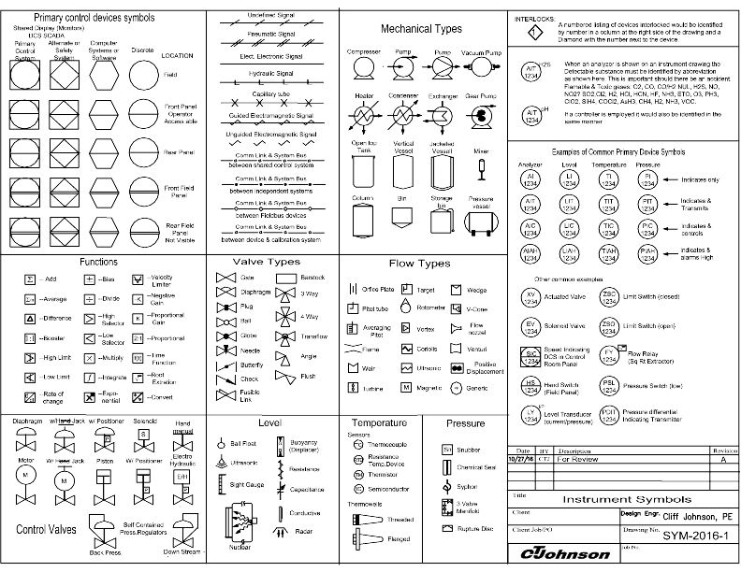

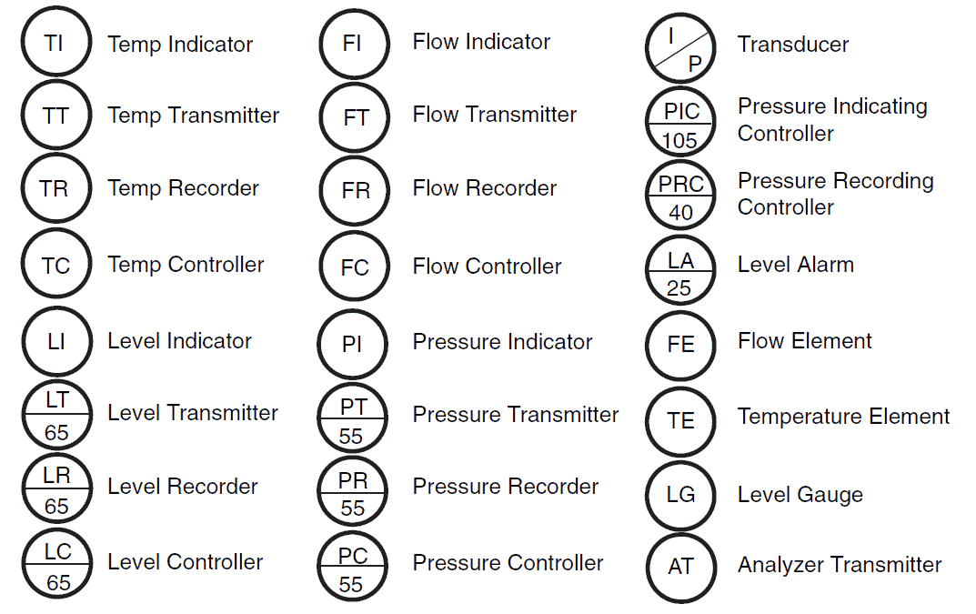

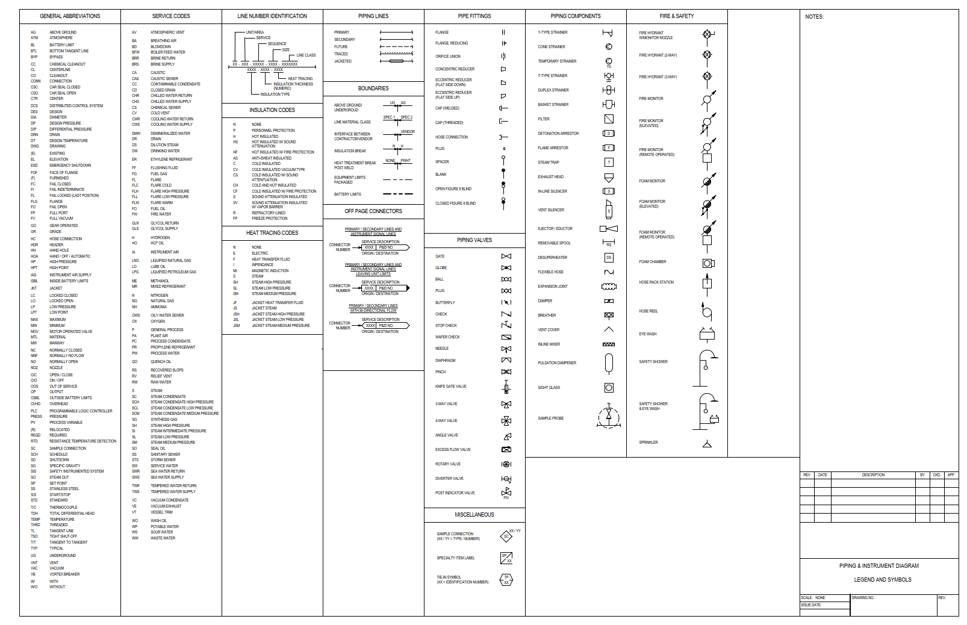

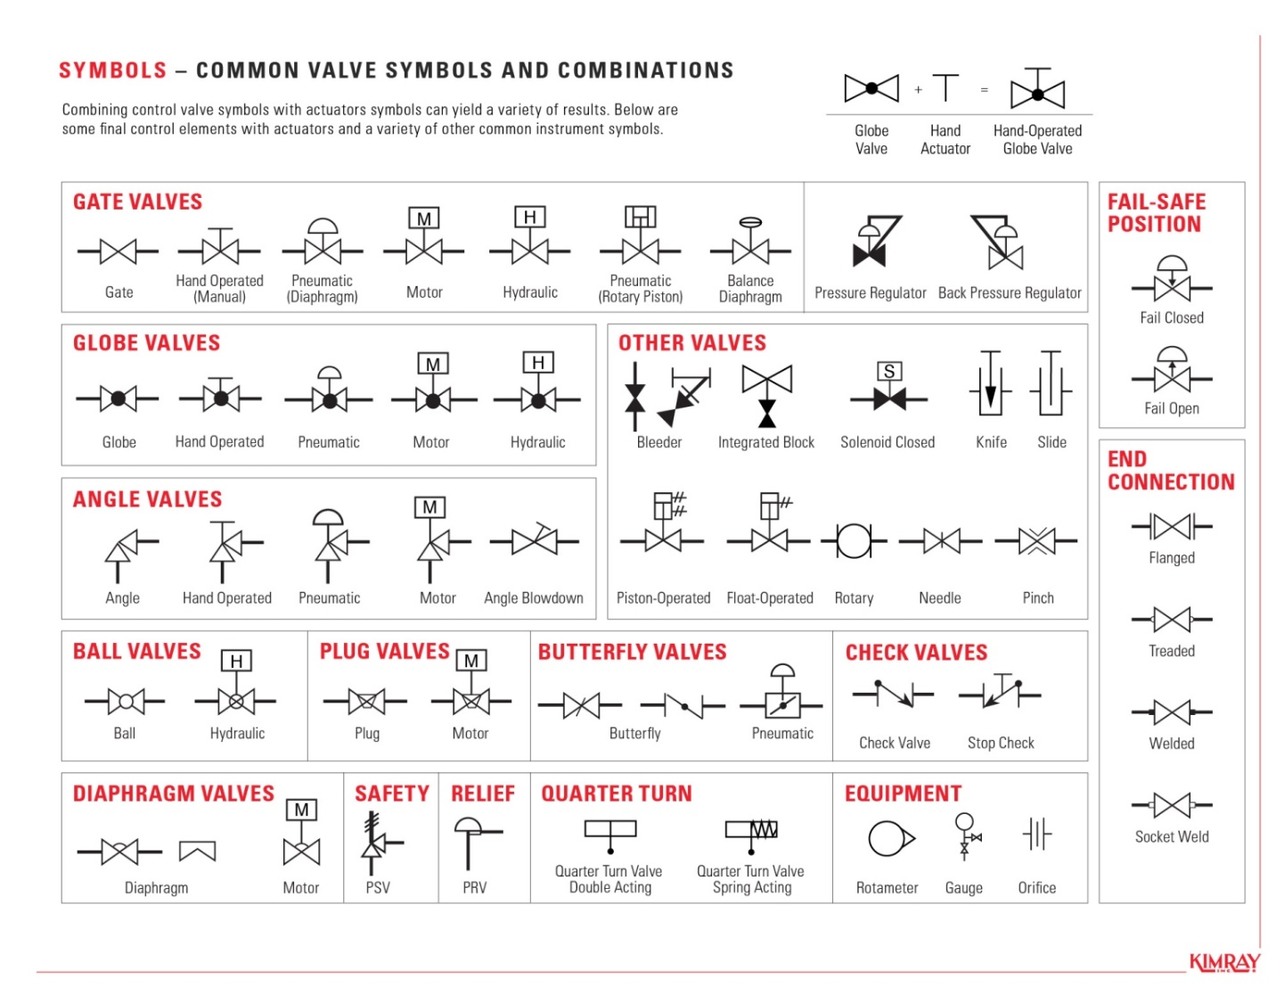

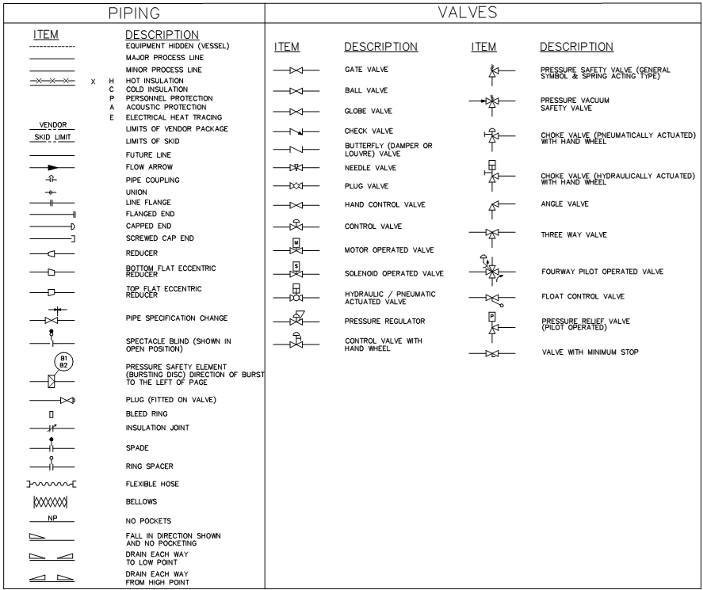

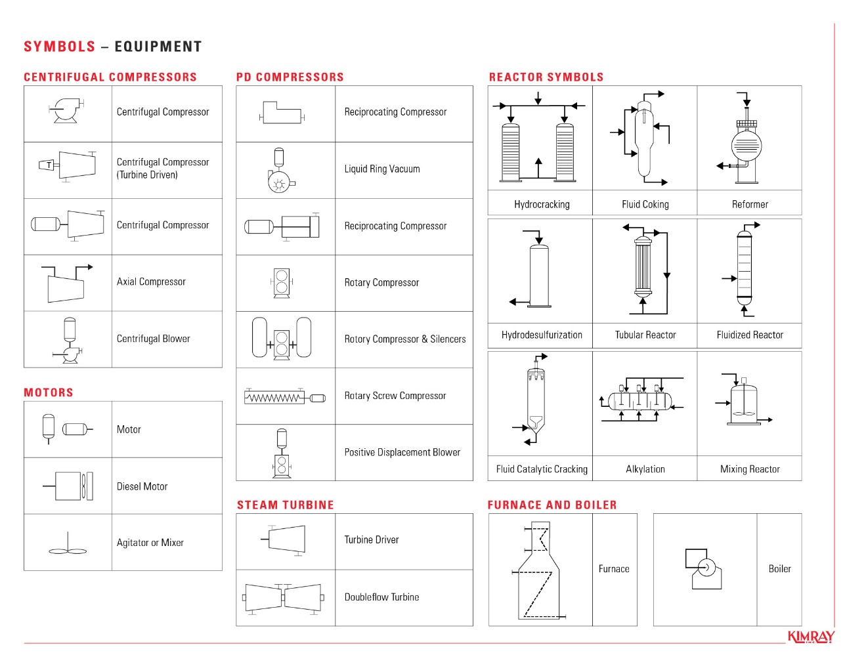

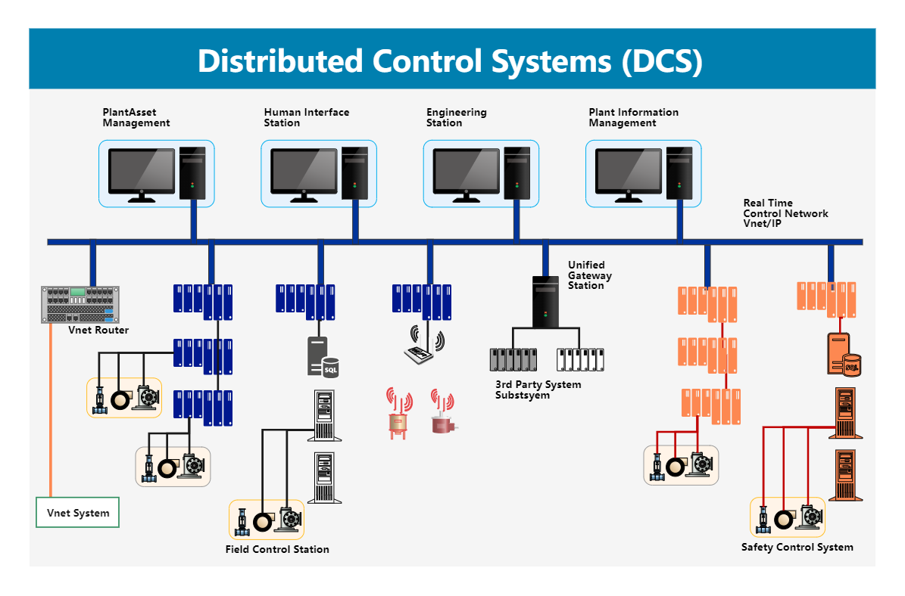

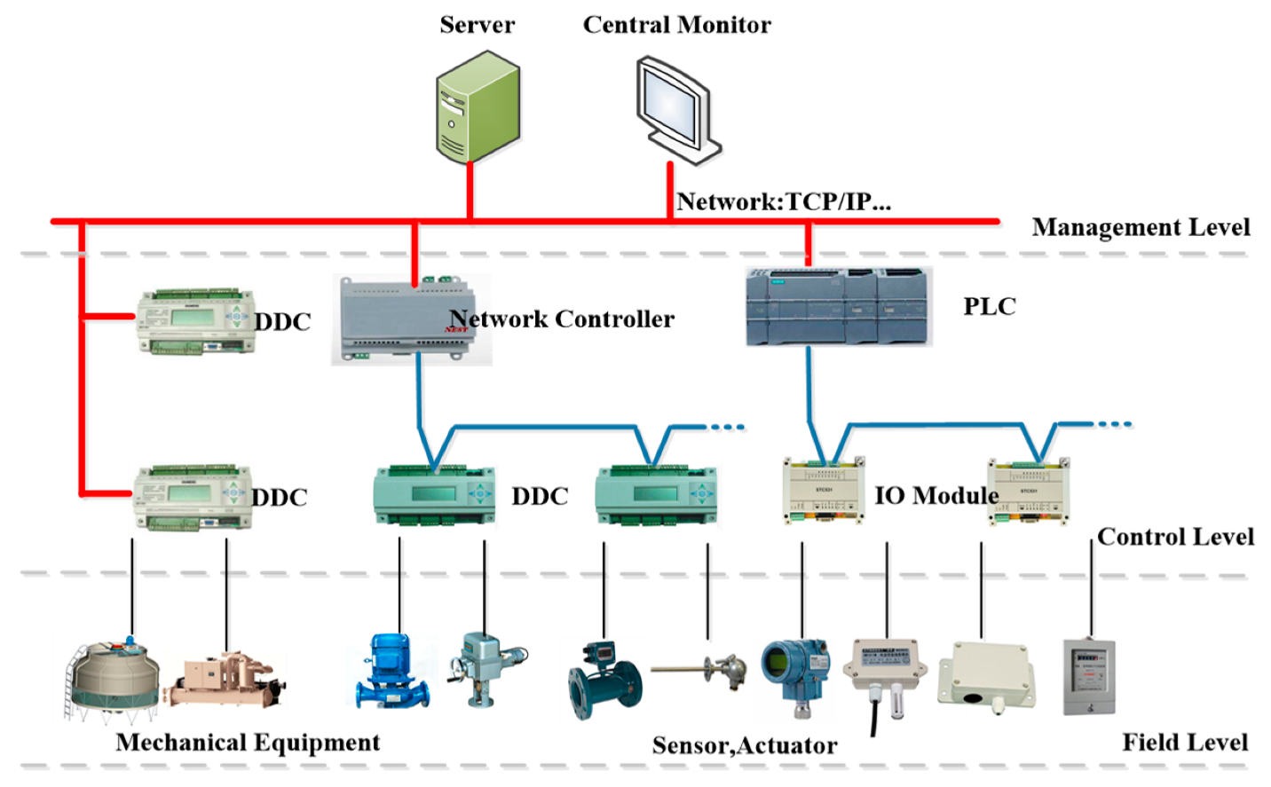

**Control Architecture**

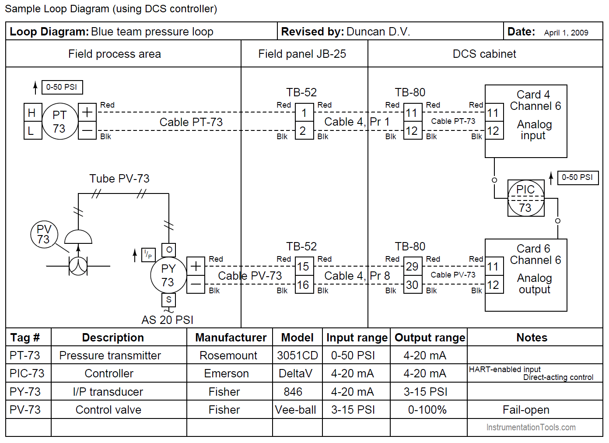

**Control Loop Diagram**

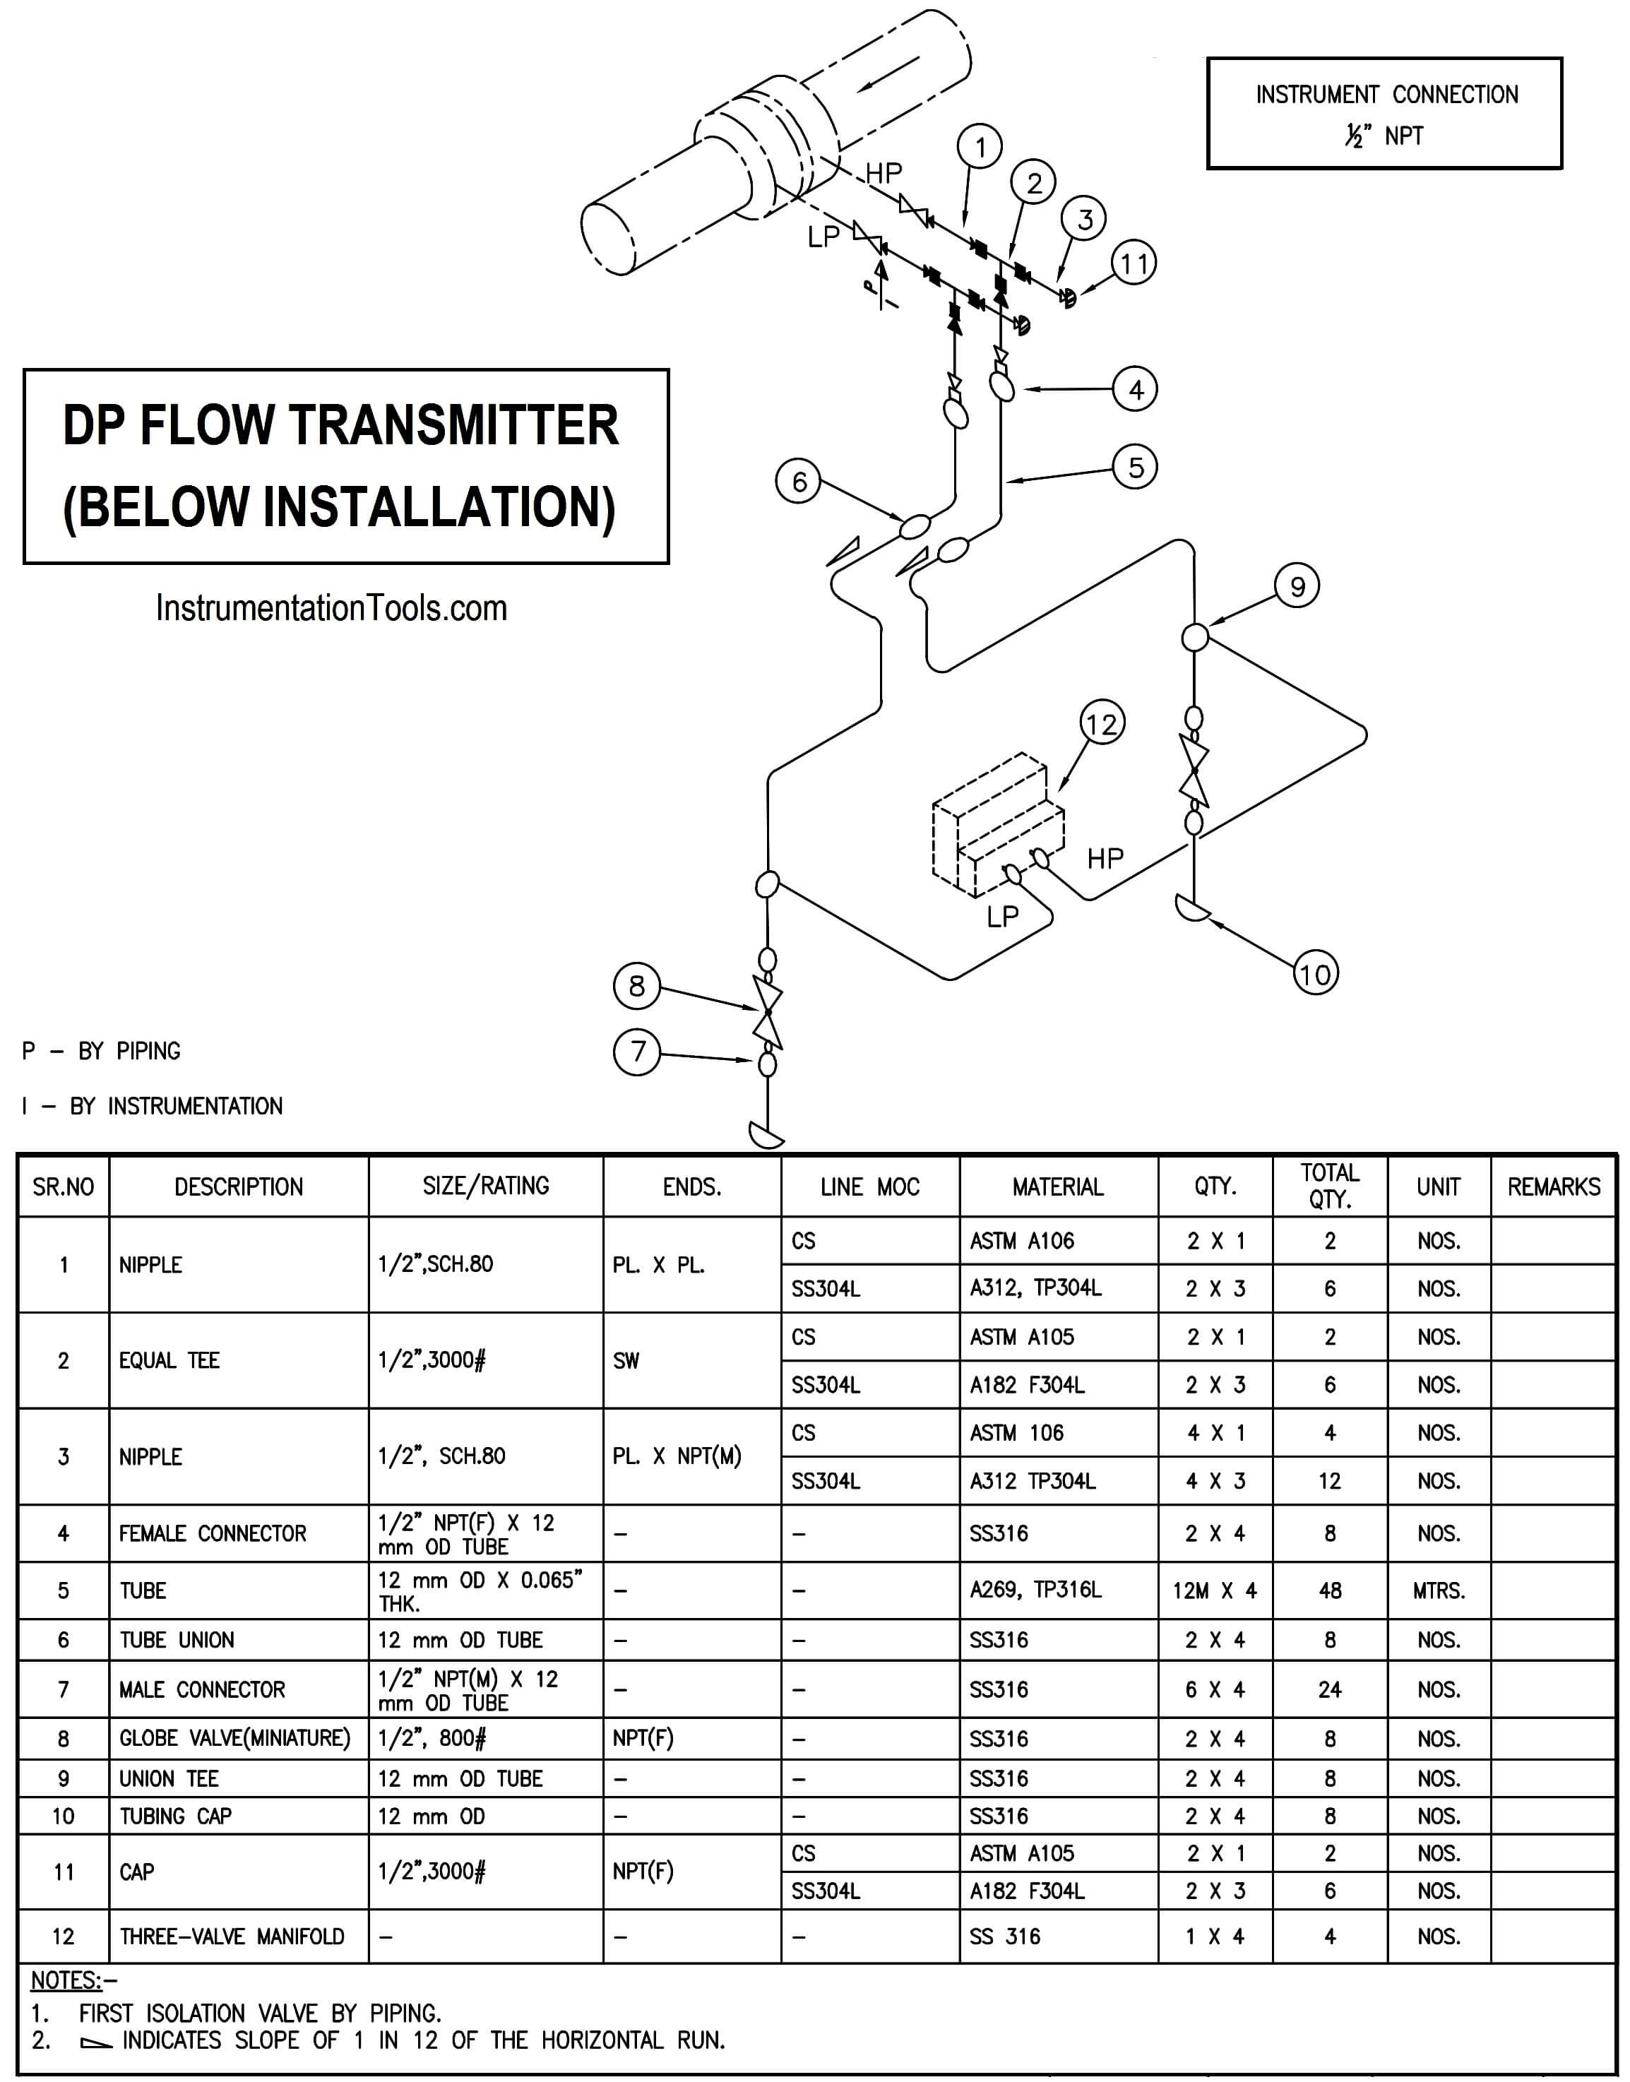

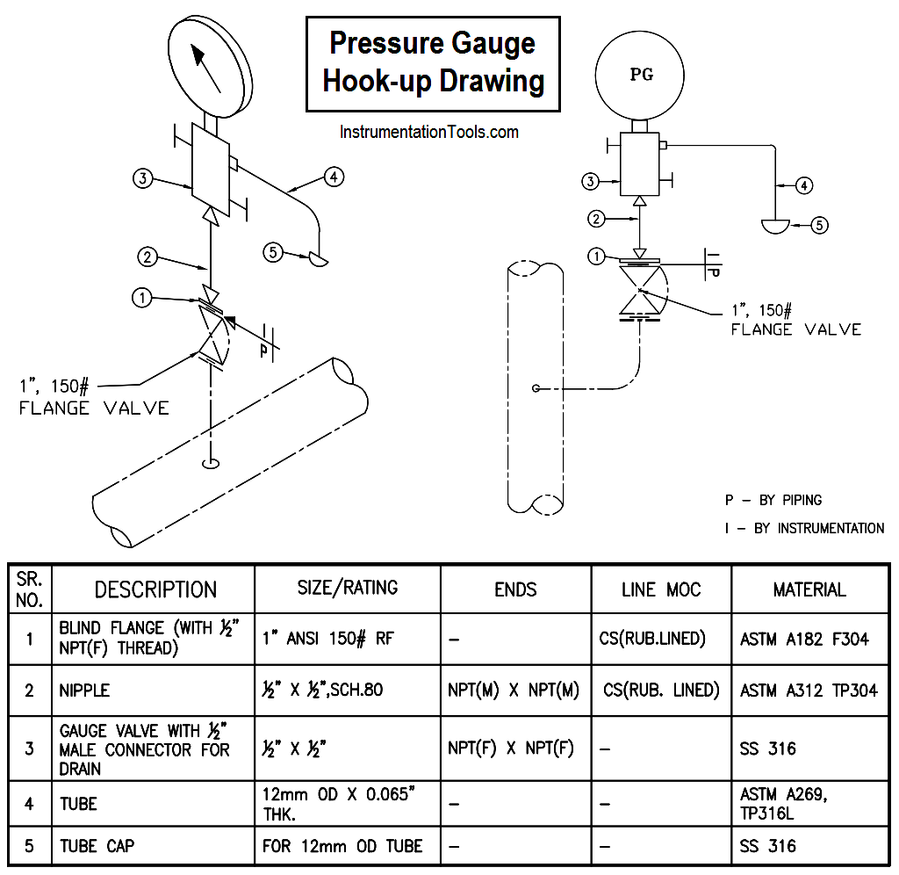

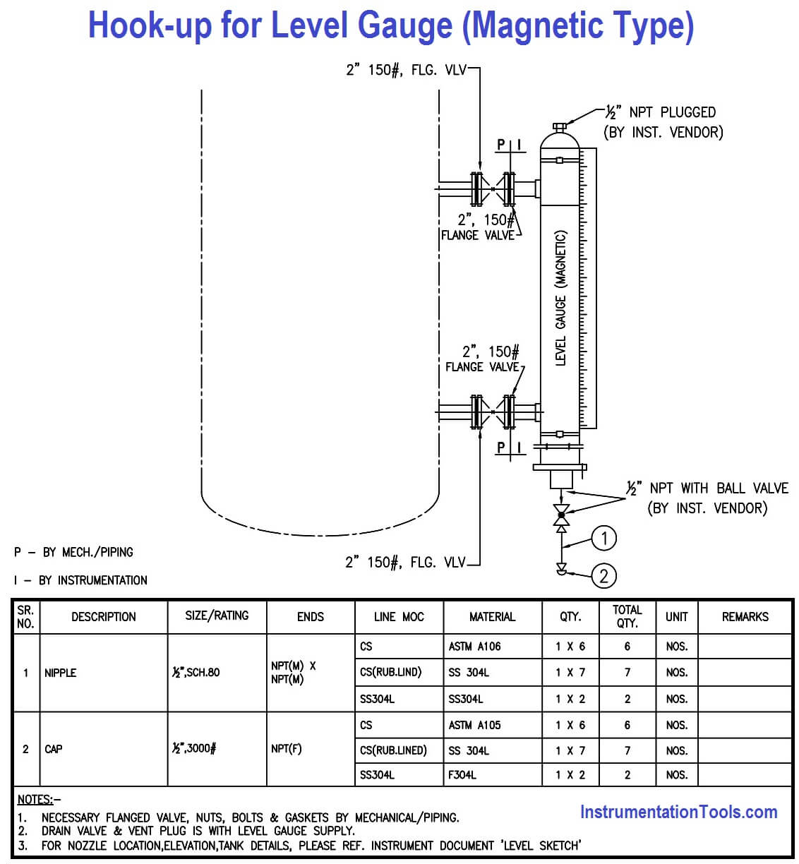

**Instrument Hook Drawing**

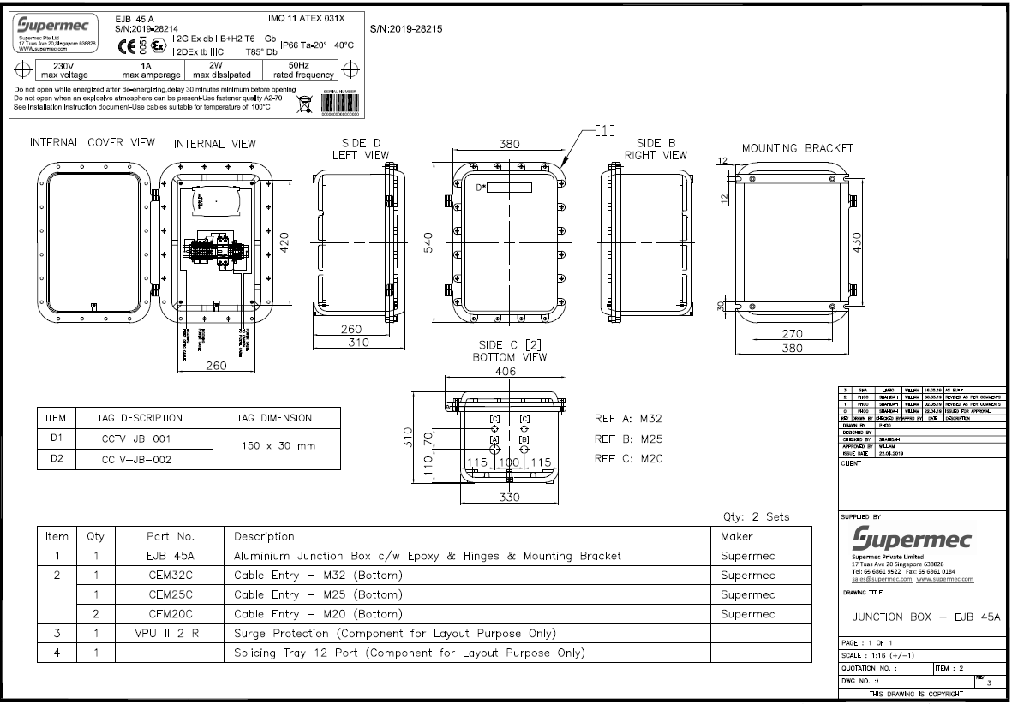

**Junction Box Drawing**

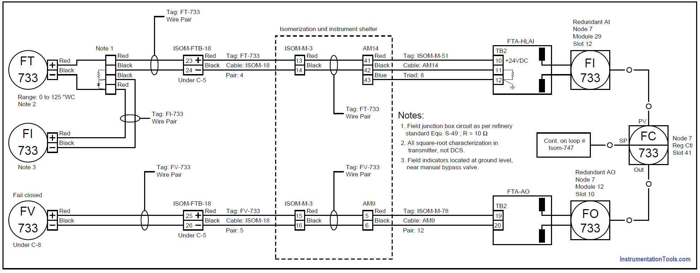

**Termination Drawing**

**Deliverable Document – Instrumentation & Control Engineer**

**1. Engineering & Design Basis**

* Instrumentation & Control Design Criteria
* Control Philosophy (Process Control, Safety, Shutdown)
* Cause & Effect Matrix (Shutdown/ESD logic, F&G logic)
* Alarm Philosophy
* Metering Philosophy (jika custody transfer)
* SIL (Safety Integrity Level) Assessment & SRS (Safety Requirement Specification)

**2. Lists & Indexes**

* Instrument Index (Tag, Service, Type, Location, Loop)
* I/O List (Input/Output untuk DCS/PLC/RTU)
* Cable Schedule (Power, Control, Signal, Fiber Optic)
* Junction Box Schedule
* Logic Index
* Material Take Off (MTO) – instrument & cabling

**3. Datasheets & Specifications**

* Instrument Datasheets (Pressure, Flow, Level, Temperature, Analyzer, Control Valve, PSV, dll.)
* Control Valve Sizing & Datasheet
* Flow Element Sizing (Orifice, Venturi, Vortex, Coriolis, dll.)
* Analyzer Specification (GC, O2, H2S, Moisture, dll.)
* Instrument Material Specification
* Control System Hardware Specification (DCS/PLC/SCADA/F&G)
* Telecommunication System Specification (FO, Radio, PA/GA)

**4. Drawings**

* P&ID (Piping & Instrumentation Diagram) dengan instrument tag
* Loop Diagrams
* Hook-Up Drawings (Installation Detail)
* Wiring Diagrams (point to point, JB to DCS/PLC)
* Termination Drawings
* Instrument Location Layout (General Arrangement, Plant Layout)
* Control Room Layout (Console arrangement, cabinet layout)
* Cable Routing Layout
* Logic Diagrams (ESD/F&G/DCS)
* Cause & Effect Diagram (graphical)
* Block Diagrams (telecom, control system, system architecture)

**5. Control System & Software**

* DCS/PLC I/O Configuration (Database, I/O mapping)
* System Architecture Diagram (DCS/PLC/RTU, F&G, telecom)
* Functional Logic Diagram (FLD)
* Sequential Function Chart (SFC)
* Alarm & Trip Set Point List
* Control Narrative (Plant operation logic)
* HMI/SCADA Graphics Design Specification

**6. Project Procurement Documents**

* RFQ (Request for Quotation) untuk vendor instrument dan control system
* Technical Bid Evaluation (TBE) – vendor instrument, control valves, DCS, PLC, F&G
* Vendor Document Review (Datasheet, GA drawing, I/O list, Logic, Cause & Effect)

**7. Construction Deliverables**

* Installation Standard & Typical Hook-up Drawing
* Cable Tray & Routing Layout
* Field Wiring Diagram
* Inspection & Test Plan (ITP) for Instruments & Control System
* Pre-commissioning & Commissioning Procedures
* Instrument Calibration Sheets
* Loop Check Procedure & Sheets

**8. Commissioning & Final Handover**

* Instrument Loop Test Reports
* Cause & Effect Test Reports
* Factory Acceptance Test (FAT) Report (DCS/PLC, Analyzer)
* Site Acceptance Test (SAT) Report
* As-Built Drawings (P&ID, Loop, Hook-up, Wiring, Layout)
* Operation & Maintenance (O&M) Manuals from Vendor
* Spare Part Lists

**Ringkasan Deliverables**

* Design Basis → Control Philosophy, Alarm, SIL
* Lists → Instrument Index, I/O List, Cable Schedule
* Specs → Datasheet, Valve Sizing, Control System Specs
* Drawings → P&ID, Loop, Hook-up, Wiring, Layouts
* System Docs → Logic, Control Narrative, HMI Spec
* Procurement → RFQ, TBE, Vendor Docs
* Construction → Hook-up, Routing, ITP, Procedures
* Commissioning → Loop Test, FAT, SAT, As-built, O&M